Method | Endpoint | Description
POST | /users/register | Create new user account
POST | /users/login | Validate credentials

POST : REGISTER

- http://localhost:7410/users/register

{
"name": "Dhanush Kumar",
"email": "dhanush@gmail.com",
"password": "abcd0123"
}
Response

200 OK
{
"id": 1,
"name": "Dhanush Kumar",
"email": "dhanush@gmail.com",
"password": "$2a$10$TaNoShZtfFaqh/KQHxC4x.I3JM0gmJzneQssxdIcha0sZ.k2kuqCa",
"accountNonExpired": true,
"accountNonLocked": true,
"authorities": [],
"credentialsNonExpired": true,
"enabled": true,
"username": "dhanush@gmail.com"
}

If any field is missing we will get below output as shown in image
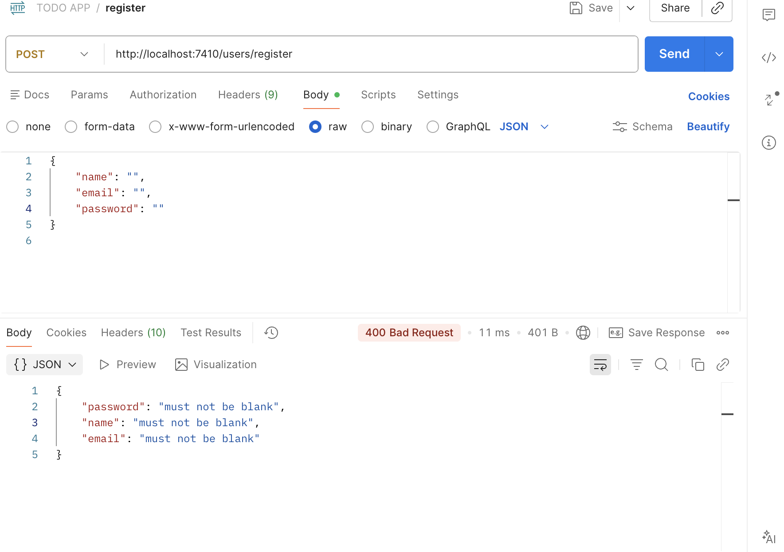

If user already exists :

Output:
Email already registered

- http://localhost:7410/users/register

{
"name": "Sri Ram",
"email": "sriram@gmail.com",
"password": "seetha345"
}
Response ➖
{
"id": 2,
"name": "Sri Ram",
"email": "sriram@gmail.com",
"password": "$2a$10$aupkYVGd9fUU12cFzpoxn.pDcZWtbHhOex0kPHZCz/nyvK3bq1L0m",
"accountNonExpired": true,
"accountNonLocked": true,
"authorities": [],
"credentialsNonExpired": true,
"enabled": true,
"username": "sriram@gmail.com"
}

POST : Login

http://localhost:7410/users/login

{
"email": "dhanush@gmail.com",
"password": "abcd0123"
}

Response :
Login successful! Use Basic Auth for tasks.

Wrong username or password:
Response : Invalid email or password

Invalid email format:
Response :
{
"email": "must be a well-formed email address"
}
Task APIs (Basic Auth: email:password)

Method | Endpoint | Description | Authorization
POST | /tasks | Create task | Any authenticated
GET | /tasks?status=TODO | List tasks | Creator/Assignee
PATCH | /tasks/{id}/status | Update status | Creator OR Assignee
DELETE | /tasks/{id} | Delete task | Creator ONLY

- Create Task - `POST /tasks`

POST : http://localhost:7410/tasks

{
"title": "Complete Backend assessment",
"description": "Backend assignment for interview",
"status": "TODO"
}

Response :
{
"id": 1,
"title": "Complete Backend assessment",
"description": "Backend assignment for interview",
"status": "TODO",
"createdAt": "2026-02-15T13:25:49.513831",
"createdBy": 1,
"assignedTo": null
}

LISTS TASKS - { STATUS OPTIONAL}

- Get Tasks - `GET /tasks`

GET : http://localhost:7410/tasks
[
{
"id": 1,
"title": "Complete Backend assessment",
"description": "Backend assignment for interview",
"status": "TODO",
"createdAt": "2026-02-15T13:25:49.513831",
"createdBy": 1,
"assignedTo": null
},
{
"id": 2,
"title": "Complete Frontend assessment",
"description": "Frontend assignment for interview",
"status": "TODO",
"createdAt": "2026-02-15T13:26:26.310263",
"createdBy": 1,
"assignedTo": null
},
{
"id": 3,
"title": "Complete FullStack assessment",
"description": "FullStack assignment for interview",
"status": "IN_PROGRESS",
"createdAt": "2026-02-15T13:26:59.371908",
"createdBy": 1,
"assignedTo": 2
}
]

- Get Tasks - `GET /tasks?status=TODO`
GET : http://localhost:7410/tasks?status=TODO

Response:
[
{
"id": 2,
"title": "Complete Frontend assessment",
"description": "Frontend assignment for interview",
"status": "TODO",
"createdAt": "2026-02-15T13:26:26.310263",
"createdBy": 1,
"assignedTo": null
}
]

- Update Task Status - `PATCH /tasks/{id}/status`
PATCH : http://localhost:7410/tasks/1/status

{
"status": "IN_PROGRESS"
}

Response :

{
"id": 1,
"title": "Complete Backend assessment",
"description": "Backend assignment for interview",
"status": "IN_PROGRESS",
"createdAt": "2026-02-15T13:25:49.513831",
"createdBy": 1,
"assignedTo": null
}

- Delete Task - `DELETE /tasks/{id}`

DELETE : http://localhost:7410/tasks/4

Response :
Task deleted successfully

